**IBM** **–** **NALAIYA** **THIRAN** **PROJECT**

**SMART** **FASHIONRECOMMENDER**

**APPLICATION**

**INDUSTRY** **MENTOR** **:**

**FACULTY** **MENTOR** **:**

**KRISHNA** **CHAITANYA**

**RAJAGURU C**

**TEAM** **ID**

**TEAM** **LEAD**

**:** PNT2022TMID43960

**:** SASISHARANAVATHY M

**TEAM** **MEMBER**

**TEAM** **MEMBER**

**TEAM** **MEMBER**

**:** BAGAVATHIATHAL P

**:** BHAVADHARANI K

**:** DEEPAK S

1

**ABSTRACT**

Fashion is perceived as a meaningful way of self-expressing that people use for different purposes. It seems to be an integral part of every person in modern societies, from everyday life to exceptional events and occasions. Fashionable products are highly demanded, and consequently, fashion is perceived as a desirable and profitable industry. Although this massive demand for fashion products provides an excellent opportunity for companies to invest in fashion-related sectors, it also faces different challenges in answering their customer needs.

In recent years, the textile and fashion industries have witnessed an enormous amount of growth in fast fashion. On e-commerce platforms, where numerous choices are available, an efficient recommendation system is required to sort, order, and efficiently convey relevant product content or information to users. Smart Fashion Recommender Application has attracted a huge amount of attention from fast fashion retailers as they provide a personalized shopping experience to consumers. Smart Fashion Recommender Application has been introduced to address these needs.

2

**TABLE** **OF** **CONTENTS**

**SL** **NO.** **CONTENTS**

**INTRODUCTION**

PROJECT OVERVIEW 1 PURPOSE

**LITERATURE** **SURVEY**

EXISTING PROBLEM 2 REFERENCES

PROBLEM STATEMENT DEFINITION

**IDEATION** **&** **PROPOSED** **SOLUTION**

EMPATHY MAP CANVAS

3 IDEATION & BRAINSTROMING

PROPOSED SOLUTION

PROBLEM SOLUTION FIT

**REQUIREMENT** **ANALYSIS**

FUNCTIONAL REQUIREMENT

4 NON-FUNCTIONAL REQUIREMENTS

**PROJECT** **DESIGN**

DATA FLOW DIAGRAMS

5 SOLUTION &TECHNICALARCHITECTURE

USER STORIES

**PROJECT** **PLANNING** **&** **SCHEDULING**

SPRINT PLANNING & ESTIMATION 6 SPRINT DELIVERY SCHEDULE

REPORTS FROM JIRA

**PAGE** **NO.**

05

06

08

13

15

18

3

**CODING** **&** **SOLUTIONING**

FEATURE 1

7 FEATURE 2 21

DATABASE SCHEMA

**TESTING**

TEST CASES 38 8 USER ACCEPTANCE TESTING

**RESULTS**

PERFORMANCE METRICS 39 9

40

**ADVANTAGES** **&** **DISADVANTAGES** 10

41

**CONCLUSION** 11

41

**FUTURE** **SCOPE** 12

**APPENDIX** 43

SOURCE CODE 13 GITHUB

4

**1.** **INTRODUCTION**

**PROJECT** **OVERVIEW**

The Fashion industryis one of the larger industries around the world. One of the things that

have remained constant throughout human civilization is humans covering their bodies with a piece of cloth. Initially, this cloth was worn as protection from the harsh climates of those ages. Later on, as we humans learned to fend for ourselves from the unforgiving climates, the cloth started to serve a different purpose. Fashion these days showcases the individuality of the person. There are many things that can be said about a person based on their fashion sense.

**PURPOSE**

There is currently no existing system that is capable of recommending clothes based on the

occasion. Different occasions call for different clothing. Moreover, a lot of fashion is basedon the color combinations of outfits. A person with no or little fashion sense will have a hard time to decide on clothes that leave a lasting impression. The proposed Fashion Recommendation System is intended to be used by individual users in order to store imagesof the clothes that they own in what is called a digital wardrobe and also to get recommendations by the system on what clothes to wear for a given occasion. The main aim of the project is to recommend the most appropriate clothes for a given occasion based on the clothes existing in the user’s wardrobe to relieve the user of the burden of making decisions about what clothing to wear. Such a system should be capable of helping someone who has no fashion sense to wear clothes that leave a good impression on others. The system should be such that it is easily accessible and easy to take advantage of the various features that it provides. One of the features should be the abilityto store images that the user uploads into a wardrobe. A wardrobe is a very useful entity that the user can use to view and manage the images of clothes that they have uploaded. This feature can also be used by the recommendation algorithm to recommend the clothes. Another feature is the classification of the type and color of the clothing that is uploaded by the user. The system should be capable ofhandling the 4 basic clothing types: Shirt, T-Shirt, Pants and Shoes.

5

**2.** **LITERATURE** **SURVEY**

**Chatbot** **design,** **consumer** **trust** **and** **privacy:** Chung, Ko, Joung, & Kim stated that

since consumers might see chatbots with negative eyes if there are privacy concerns, consumer trust is another factor that can be explored further. Aspects such as transparent advice and problem-solving could be investigated in future research, addressing the role that design plays in this context and if other factors (e.g. social elements, cultural values, self- identity) inﬂuence consumer’s trust on chatbots.

**Multi-user** **chatting**: Merrilees and Miller observed that traditional shopping with a

companion inﬂuences the consumer experience. Alone consumers tend to be more price

sensitive. Future studies may explore the way fashion consumers seek for advice from chatbots

that could be experimented with by adjusting social factors (e.g. including a friend in the

conversation), evaluating the impact of these factors on user acceptance levels.

**Design** **bots:** Colombi, Kim, & Wyatt suggested that fashion chatbots may be made to

behave as a fashion designer, providing a platform to support co-creation of value.

Conversational platforms can provide insights for brands to recognize consumer value, which

means that future research in this area can also enhance the consumer experience.

**Consumer** **autonomy** **and** **identity** **in** **chatbot** **consumer** **experience:** Ameen, Hosany, & Tarhini suggested that consumer autonomy is related to the perceived sense of control that consumers have over theinteraction with chatbots and it can be attached to motivational factors. Future studies might address the role that consumer autonomy and identity play in consumer trust and acceptance, for example, by measuring chatbots design approaches that can trigger these states.

6

**2.1** **EXISTING** **PROBLEM:**

In existing system only simple web application and their rating has been implementedin existingsystem,An ecommerce product recommendation engine is a piece of technology that displays recommended products to shoppers throughout your store. It uses machine learning to get smarter and show increasingly relevant products to shoppers based on their interests and previous browsing behavior.

**REFERENCES:**

1. GloablInfoResearch: Global Fast Fashion Apparel Market 2021 by Key Countries,

Companies, Type and Application. GloablInfoResearch, HongKong, 2021.

2. Hou, M., Wu, L., Chen, E., Li, Z., Zheng, V. W., & Liu, Q.:Explainable fashion

recommendation: A semantic attribute region guided approach. In Proceedings of the 28th

Twenty-Eighth International Joint Conference on Artificial Intelligence, 2019; pp. 4681-

4688.

3. Hidayati, S. C., Hsu, C. C., Chang, Y. T., Hua, K. L., Fu, J., & Cheng, W. H.: What Dress

Fits Me Best? Fashion Recommendation on the Clothing Style for Personal Body Shape. In

Proceedings of the 26th ACM International Conference on Multimedia (MM '18).

Association for Computing Machinery, New York, NY, USA, 2018; pp. 438-446.

4. Wang, H., Wang, N., & Yeung, D. Y.: Collaborative Deep Learning for Recommender

Systems. In Proceedings of the 21th CM SIGKDD International Conference on Knowledge

Discovery and Data Mining, New York, 2015; pp. 1235- 1244.

5. McAuley, J., Targett, C., Shi, Q., & Van Den Hengel, A.: Image-based Recommendations

on Styles and Substitutes. In Proceedings of the 38th International ACM SIGIR Conference

on Research and Development in Information Retrieval, 2015; pp. 43-52. 2015.

7

**2.2** **PROBLEM** **STATEMENT** **DEFINITION**

The personal information collected by recommenders raises the risk of

unwanted exposure of that information. Also, malicious users can bias or

sabotage the recommendations that are provided to other users. In recent years,

the textile and fashion industries have witnessed an enormous amount of

growth in fast fashion. On e-commerce platforms, where numerous choices are

available, an efficient recommendation system is required to sort, order, and

efficiently convey relevant product content or information to users.

➢The problem of the work is to design static web applications deployments with customer deployment

➢Lack of interaction between application and user

➢ User need to navigate across multiple pages to choose right product ➢ Confusion in choosing product

➢Lack of sales ➢Complex User Interface. ➢ Lack of proper guidance.

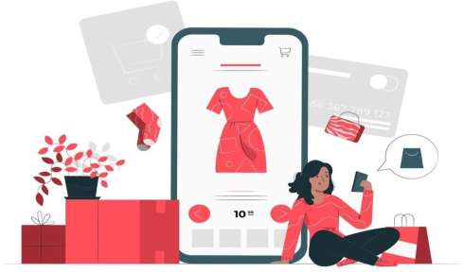8

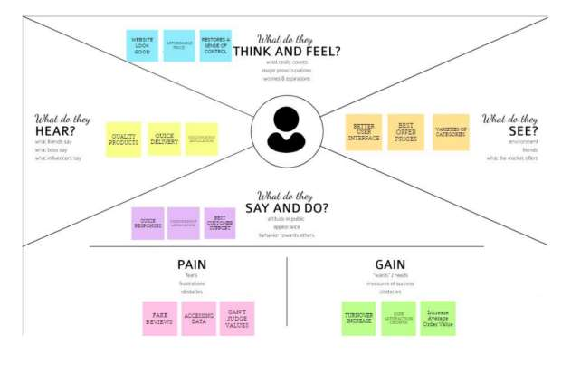

**3.IDEATION** **&** **PROPOSED** **SOLUTION**

**3.1** **EMPATHY** **MAP** **CANVAS:**

An empathy map is a simple, easy-to-digest visual that captures knowledge about a user’s behaviours and attitudes. It is auseful tool to helps teams better understand theirusers. Creating an effective solution requires understanding the true problem and the person who is experiencing it. The exercise of creating the map helps participants consider things from the user’s perspective along with his or her goals and challenges. An empathy map is a collaborative tool teams can use to gain a deeper insight into their customers.

SMART FASHION RECOMMENDER APPLICATION



9

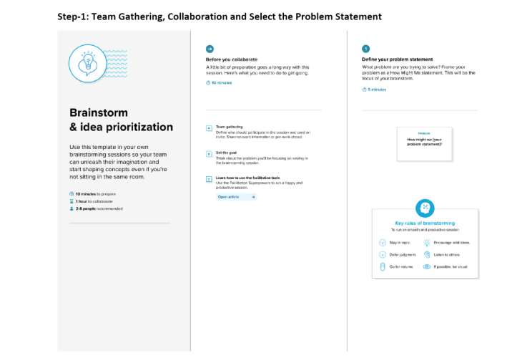

**3.2** **IDEATION** **&** **BRAINSTROMING:**

A group problem-solving technique that involves the spontaneous contribution

of ideas from all members of the group.

The mulling over of ideas by one or more individuals in an attempt to

devise or find a solution to a problem.

10

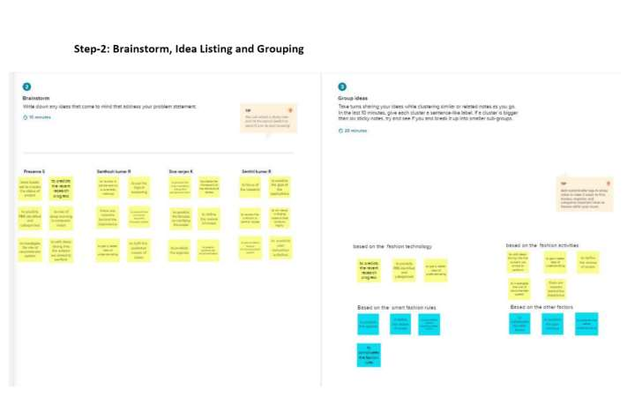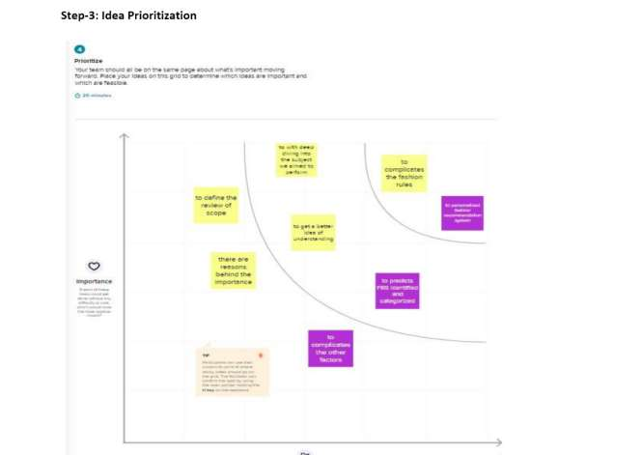

11

**3.PROPOSED** **SOLUTION:**

SMART FASHION RECOMMENDER APPLICATION



|  |  |  |
| --- | --- | --- |
| **S.NO.** | **PARAMETER** | **DESCRIPTION** |
| **1.** | **Problemstatement(problem**  **to** **be** **solved)** | • In E-commerce websites, users need to search for products and navigate across screens to view the product and order product.  • A new innovative solution came up through which can directly make online shopping based on the choice of the user without any search.  • It can be done by using the chatbot which can be achieved by a smart fashion recommender application. |
| **2.** | **Idea/** **solution** **description** | • Thesmart fashion recommender application leverages the use of a chatbot to interact with the users, gather information about their preferences, and recommend suitable products to the users.  • User can be able to mention their preferences by interacting with chatbot.  • The user must receive a notification on order confirmation/failure.  • The chatbot must gather feedback from the user at the end of order confirmation |
| **3.** | **Novelty/** **Uniqueness** | • Chatbot asks and learns from user preference which recommends appropriate products to the user without making them search through various filters which reduces time and thus increases sales.  • Instead of searching manually a chatbot will help to find the right product effectively, with this feature user can save time and it is an easy process, chat keep sending a notification about new collections |
| **4.** | **Social** **impact/Customer**  **satisfaction** | • Feedback from the user at the end of the session or after placing an order is one of the most important factors in deriving customer satisfaction and providing better services.  • The model can recommend products that are more suitable to the customer.  • Directlydo online shopping based on customer |

12

|  |  |  |
| --- | --- | --- |
|  |  | choice without any search.  • It can also save a lot of time. |
| **5.** | **Business** **model**  **(Revenuemodel)** | • Due to market dynamics and customer preferences, there is a large vocabulary of distinct fashion products, as well as high turnover.  • This leads to sparse purchase data, which challenges the usage of traditional recommender systems.  • Better experience and Feasibility. |
| **6.** | **Scalability** **of** **the** **solution** | • The solution can be made scalable by using micro service architecture provided that each server is responsible for certain functionalityof the application.  • Storing user preferences along with the product in the browser cookie will enable it to provide a response instantly and allows for fetching related products.  • The scalabilitycan be increased by increasing the number of products and also the accuracy of the product suggestions |

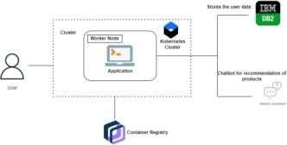

13

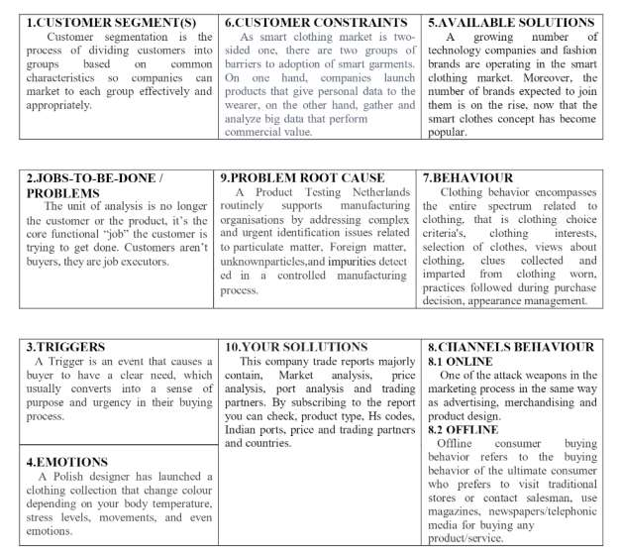

**3.3** **PROBLEM** **SOLUTIONFIT**

14

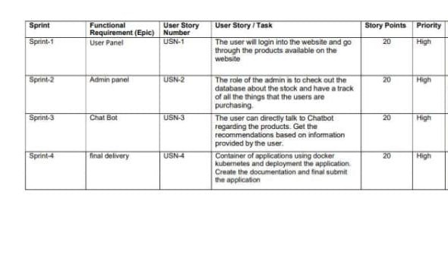

**4.** **REQUIREMENT** **ANALYSIS**

**4.1** **FUNCTIONAL** **REQUIREMENTS:**

**SMART** **FASHION** **RECOMMENDER** **APPLICATION**

15

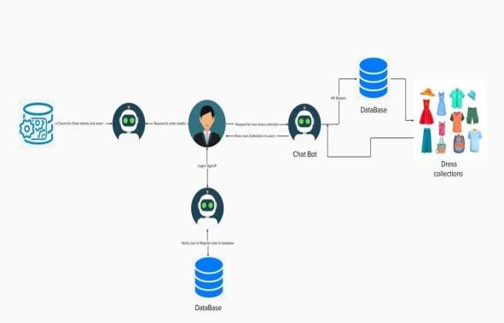

**5.** **PROJECT** **DESIGN**

**5.1** **DATA** **FLOW** **DIAGRAMS:**

A Data Flow Diagram (DFD) is a traditional visual representation of the

information flows within a system. A neat and clear DFD can depict the right

amount of the system requirement graphically. It shows how data enters and

leaves the system, what changes the information, and where data is stored.

16

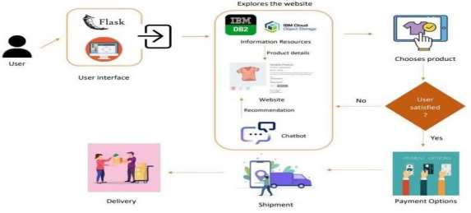

**5.2** **SOLUTION** **&** **TECHNICAL** **ARCHITECTURE:**

We have developed a new innovative solution through which you can directly do your

online shopping based on your choice without any search. It can be done by using the chat-

bot. In this project you will be working on two modules:

• Admin

• User

Instead of searching for products in the search bar and navigating to individual products to find

requiredpreferences,this project leverages the useof chatbots to gatherallrequired preferences

and recommend products to the user. The solution is implemented in such a way as to improve

the interactivity between customers and applications. The chatbot sends messages periodically

to notify offers and preferences. For security concerns, this application uses a token to

authenticate and authorize users securely. The token has encoded user id and role. Based onthe

encoded information, access to the resources is restricted to specific users.

17

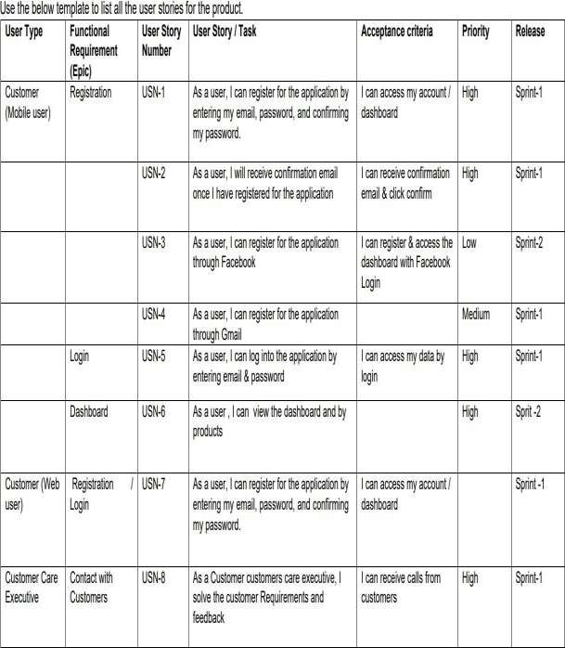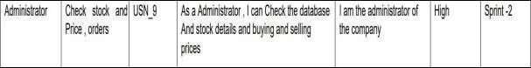

**5.3** **USER** **STORIES:**

18

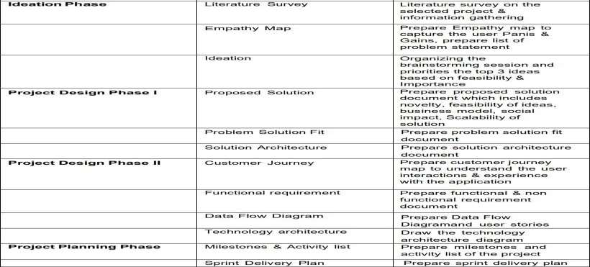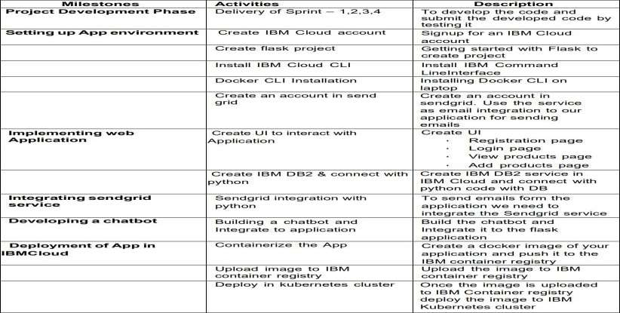

**6.** **PROJECT** **PLANNING** **&** **SCHEDULE** **6.1** **SPRINT** **PLANNING** **&** **ESTIMATION:**

19

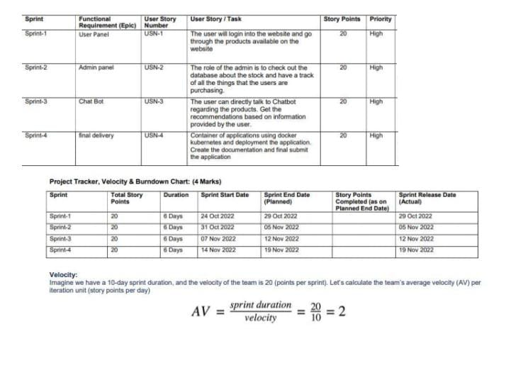

**6.2** **SPRINT** **DELIVERY** **SCHEDULE:**

20

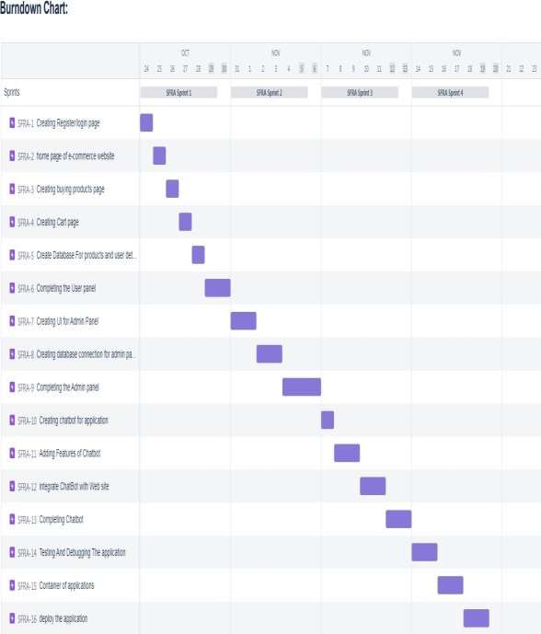

**6.3** **REPORTS** **FROM** **JIRA:**

21

**7.** **CODING** **&** **SOLUTIONING**

**FEATURE1:**

**7.1homepage.html**

<html> <head>

<title> BEYOND FASHION </title> </head>

<style> *{

margin:0; padding: 0;

font-family: "Times New Roman", Times, serif; }

.main{

width: 100%;

background-color: #131315; background-position:center; background-size: cover; height: 200%;

font-family: "Times New Roman", Times, serif; }

.navbar{ width: 100%; height: 75px; margin: auto;

} .icon{

width: 1000px; float: left; height: 70px;

} .logo{

color:#FFFFFF; font-size: 35px;

padding-left: 20px; float: left;

padding-top: 10px; }

.menu{

width: 400px; float: left; height: 70px;

} ul{

float: left; display: flex;

justify-content:center; align-items: center;

}

ul li{ 22

list-style: none;

23

margin-left: 62px; margin-top: 27px; font-size: 15px;

}

ul li a{

text-decoration: none; color: #FFFFFF;

font-weight: bold; transition: 0.4s ease-in-out;

}

ul li a:hover{

color: rgb(98, 246, 152);

}

.search{ width: 330px; float: left;

margin-left: 270px; }

.srch{

width: 200px; height: 40px;

background: transparent;

border: 1px solid rgb(98, 246, 152); margin-top: 13px;

color: #FFFFFF; border-right: none; font-size: 16px; float: left; padding: 10px;

border-bottom-left-radius:5px; border-top-left-radius: 5px;

}

.btn{

width: 100px; height: 40px;

background:rgb(98, 246, 152) ; border: 2px solid rgb(98, 246, 152); margin-top: 13px;

color: #FFFFFF; font-size: 15px;

border-bottom-right-radius: 5px; border-bottom-right-radius: 5px;

}

.btn:focus{ outline: none;

}

24

.srch:focus{ outline: none;

}

.content{ width: 1200px; height: auto; margin: auto; color: #800080;

position: relative; }

.content.par{ padding-left: 20px;

padding-bottom: 25px;

letter-spacing: 1.2px; line-height: 30px;

}

.content h1{

font-size: 50px; padding-left: 20px; margin-top: 9%; letter-spacing: 2px;

}

.content .cn{ width: 160px; height: 40px;

background: rgb(98, 246, 152); border: none;

margin-bottom: 10px; margin-left: 20px; font-size: 18px; border-radius: 10px; cursor: pointer; transition: .4s ease;

}

.content .cn a{

text-decoration: none; color: #FBE7A1; transition: .3s ease;

}

.cn:hover{

background-color: #FBE7A1; }

.content span{ color:rgb(98, 246,152); font-size: 60px;

}

25

.form{

width: 250px; height:380px;

background: linear-gradient(to top,hsla(89, 43%, 51%, 0.3)); position: absolute;

top: -20px; left:870px;

border-radius: 10px; padding: 25px;

}

.form h2{ width:220px;

text-align: center; color:rgb(98, 246,152); font-size: 22px;

border-radius: 10px; margin: 2px; padding: 8px;

}

.form input{ width: 240px; height: 35px;

background: rgba(0, 255, 0, 0.5); }

.form input{ width: 240px; height: 35px;

background: rgba(0, 255, 0, 0.5);

border-bottom: 1px solid rgb(98, 246, 152); border-top: none;

border-right: none; border-left: none; color: #fff;

font-size: 15px; letter-spacing: 1px; margin-top: 30px;

}

.form input:focus{ outline: none;

}

::placeholder{ color: #fff;

}

.btnn{

width: 240px; height: 40px;

26

background: rgb(98, 246, 152); border: none;

margin-top: 30px; font-size: 18px; border-radius: 10px; cursor: pointer; color: #fff; transition: 0.4s ease; }

.btnn:hover{ background: #fff;

color: rgb(98, 246, 152); }

.btnn a{

text-decoration: none; color: #000;

font-weight: bold; }

.form.link{

font-size: 17px; padding-top: 20px; text-align: center;

}

.form .link a{

text-decoration: none; color: rgb(98, 246, 152);

}

.liw{

padding-top: 15px; padding-bottom: 10px; text-align: center;

}

img{ width:1300px; color: yellow;

height: 400px; float:left ;

} </style> <body>

<divclass="main"> <divclass="navbar">

<divclass="icon">

<h2 class="logo">FASHIONISTA</h2> </div>

27

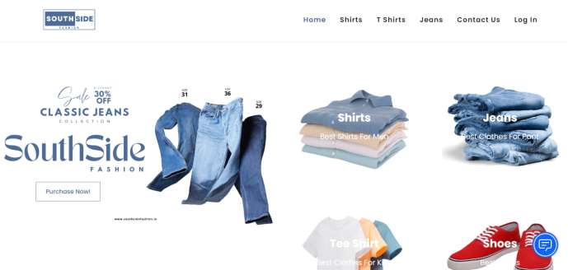

<div class="menu"> <ul>

<li><a href="#">HOME</a></li> <li><a href="#">ABOUT</a></li>

</ul> </div>

<div class="search">

<input class="srch" type="search" name="" placeholder="TYPE TO SEARCH"> <a href="#"><button class="btn">SEARCH</button></a>

</div>

<img src="https://smartfashionsfra.s3.jp-tok.cloud-object-storage.appdomain.cloud/istockphoto-831318986-170667a.jpg">

</div> </div>

</body> </html>

28

**FEATURE** **2:**

**7.2** **finalhome.html:** <html>

<head>

<meta name="viewpoint" content="width=device-width, initial-scale=1.0">

<title>BEYONDFASHION</title>

<linkrel="stylesheet"href="https://storagedemo-madzh.s3.jp-tok.cloud-object-storage.appdomain.cloud/MadmukFinalhomecss.css">

</head>

<body>

<nav>

<a class="logo" href="MadFinalhome.html"><h2>FASHIONISTA HOME</h2></a>

<ul>

<li><input class="srch" type="search" name="" placeholder="TYPE TO SEARCH">

<a href="#"><button class="btn">SEARCH</button></a></li>

<li><a href="#">HOME</a></li>

<li><a href="#">FEATURES</a></li>

<li><a href="#">ABOUT</a></li>

</ul>

<img src="https://storagedemo-madzh.s3.jp-tok.cloud-object-storage.appdomain.cloud/images/profile.jpeg" class="user-pic" onclick="toggleMenu()">

<div class="sub-menu-wrap" id="subMenu">

<divclass="sub-menu">

<div class="user-info">

<img src="https://storagedemo-madzh.s3.jp-tok.cloud-object-storage.appdomain.cloud/images/profile.jpeg">

<h2>NAME</h2>

</div>

<hr>

<a href="#" class="sub-menu-link">

<img src="https://storagedemo-madzh.s3.jp-tok.cloud-object-storage.appdomain.cloud/images/profile.jpeg">

<p>EDIT PROFILE</p>

</a>

29

<a href="#" class="sub-menu-link">

<img src="https://storagedemo-madzh.s3.jp-tok.cloud-object storage.appdomain.cloud/images/settings.jpeg">

<p>SETTING & PRIVACY</p>

</a>

<a href="#" class="sub-menu-link">

<img src="https://storagedemo-madzh.s3.jp-tok.cloud-object-storage.appdomain.cloud/images/help.jpeg">

<p>HELP</p>

</a>

<a href="/Login" class="sub-menu-link">

<img src="https://cdn-icons-png.flaticon.com/512/56/56805.png">

<p>LOGOUT</p>

</a>

</div>

</div>

</nav>

<div class="Banner">

<divclass="Bannerimg1"> <img imgclass="image" src="https://img.freepik.com/free-photo/joyful-parisian-woman-beret-sunglasses-points-place-text-purple-wall_197531-24604.jpg?w=2000"></div>

<div class="Adcontent">

<h1><br>BEST FASHION FOR WOMEN</br></h1>

<br>ADD THESE NEW LAUNCHES TO YOUR CART NOW...</br>

</div>

</div>

<div class="rowstart">

<div class="columnst"> <div class="depimg"><img class="image" src="https://cdn0.weddingwire.in/article/2617/original/1280/jpg/107162-wedding-dresses-for-girls-6.jpeg"> </div> <div class="Bottom">WEDDING & FESTIVE</div> </div>

<div class="columnst"> <div class="depimg"><img class="image" src="https://previews.123rf.com/images/vadymvdrobot/vadymvdrobot1801/vadymvdrobot180102335/941227 85-full-length-image-of-smiling-asian-woman-in-business-clothes-and-eyeglasses-holding-smartphone-while.jpg"> </div> <div class="Bottom">BACK TO DESK</div> </div>

<div class="columnst"> <div class="depimg"><img class="image" src="https://i.pinimg.com/474x/29/00/fa/2900fa4d1599631766420338e531b2b2.jpg"> </div> <div class="Bottom">VACAY MOOD</div> </div>

30

<div class="columnst"> <div class="depimg"><img class="image" src="https://img.faballey.com/images/Product/DRS02948Z/1.jpg"> </div> <divclass="Bottom">PARTYALL NIGHT</div> </div>

</div>

<div class="Banner">

<div class="Bannerimg2"> <img img class="image" src="https://bluejay.com.my/wp-content/uploads/2021/12/Kids-clothes-Hong-Kong-seed.jpg"></div>

<divclass="Adcontent2">

<h1><br>KIDS FASHION</br></h1>

<br>LET OUR FUTURE BE STYLISH....</br>

</div>

</div>

<div class="row">

<div class="column"> <div class="depimg"><img class="image" src="https://cdn.shopify.com/s/files/1/0266/6276/4597/files/floral_ethnic_wear_for_kids_by_utsa.jpg?v=15978 33877"> </div> <div class="Bottom">ETHNIC WEAR</div> </div>

<div class="column"> <div class="depimg"><img class="image" src="https://i.pinimg.com/736x/8a/f8/59/8af859d60ef9667726b206e1be2378e4.jpg"> </div><div class="Bottom">WINTER WEAR</div> </div>

<div class="column"> <div class="depimg"><img class="image" src="https://i.pinimg.com/474x/9a/c2/85/9ac28569bd3bade0aa23bd74aaa8c0a9.jpg"> </div><div class="Bottom">DRESSES & JUMPSUITS</div> </div>

<div class="column"> <div class="depimg"><img class="image" src="https://i.pinimg.com/564x/1b/c1/d5/1bc1d56f08959760738a0386f231d3fc.jpg"> </div> <div class="Bottom">TOPS & TEES</div> </div>

</div>

<div class="Banner">

<div class="Bannerimg1"> <img img class="image" src="https://images.hindustantimes.com/rf/image_size_630x354/HT/p2/2018/01/30/Pictures/_21667342-05ba-11e8-90ea-37dc70df54a3.jpg"></div>

<div class="Adcontent">

<h1><br>MENS FASHION</br></h1>

<br>WE ALSO PROVIDE TRENDY COLLECTIONS FOR MEN..ALWAYS "MEN WILL BE MEN"</br>

</div>

</div>

<div class="row">

<div class="column"> <div class="depimg"><img class="image" src="https://encrypted-tbn0.gstatic.com/images?q=tbn:ANd9GcRPYVjlrL-LxLn_nhnDfHJx09_dUQsTRgkM69nENo7WKE6EKe555GjYDI7leLNGsKyGvR8&usqp=CAU"> </div> <div class="Bottom">T-SHIRTS & POLOS</div> </div>

<div class="column"> <div class="depimg"><img class="image" src="https://encrypted-

31

tbn0.gstatic.com/images?q=tbn:ANd9GcTIFeIqHpb2srr3FnKvSDnAUdz225j0v_Ijo-KuIZzvS2O5LHuyxBNYzfy8HgQ_Hi6WbDQ&usqp=CAU"> </div> <divclass="Bottom">CASUAL SHIRTS</div> </div>

<div class="column"> <div class="depimg"><img class="image" src="https://assets.myntassets.com/dpr_1.5,q_60,w_400,c_limit,fl_progressive/assets/images/10498568/2020/6 /10/f1bc48ac-9997-4be1-8ce3-81cc6d5e61061591736177979-HRX-by-Hrithik-Roshan-Men-Grey-Solid-Regular-Fit-Training-Jo-1.jpg"> </div> <div class="Bottom">SPORTS WEAR</div> </div>

<div class="column"> <div class="depimg"><img class="image" src="https://images.express.com/is/image/expressfashion/0037_04105431_0512?cache=on&wid=361&fmt=jp eg&qlt=75,1&resmode=sharp2&op_usm=1,1,5,0&defaultImage=Photo-Coming-Soon"> </div> <div class="Bottom">SWEATSHIRTS & JACKETS</div> </div>

</div>

<div class="Banner">

<div class="Bannerimg2"> <img class="image" src="https://lh3.googleusercontent.com/KDJ_WZU_7c-GHi14G03oqXb6ZSgTiDJr8L7Rid5jA9pRPAdUOgfQQYAPDLGN9Sn3eJC6B1F4qchid_0mHWn_jficXrs= w400-rw"></div>

<divclass="Adcontent2">

<h1><br>ACCESSORIES</br></h1>

<br>THE ANOTHERTHING WHICH MAKES A PERSON FASHIONABLE IS ACCESSORIES</br>

</div>

</div>

<divclass="rowend">

<div class="columnend"> <div class="depimg"><img class="image" src="https://5.imimg.com/data5/FJ/AH/MY-42396081/combo-sets-28american-diamond-jewellery-29-500x500.jpg"> </div> <div class="Bottom">JEWELLERY</div> </div>

<div class="columnend"> <div class="depimg"><img class="image" src="https://encrypted-tbn0.gstatic.com/images?q=tbn:ANd9GcTaoxLoX2lgaVWFtaGkCvyrozucBLTpaV4LJd9xx2sRoqoums9kp9s oRVXOKw6_rkVxsZk&usqp=CAU"> </div> <div class="Bottom">SUNGLASSES</div> </div>

<div class="columnend"> <div class="depimg"><img class="image" src="https://encrypted-tbn0.gstatic.com/images?q=tbn:ANd9GcRJKjvaIU1qatbXinxMNRfWE338fXEl7t69TQ&usqp=CAU"> </div> <div class="Bottom">WATCHES</div> </div>

<divclass="columnend"> <divclass="depimg"><img class="image" src="https://encrypted-tbn0.gstatic.com/images?q=tbn:ANd9GcQSWDKgpQeZ-3VNR7-9SfaVGVvqOawrkZiLdNfSpjNNQJNI6hl8cJg0Qs_DZfpJtizUst0&usqp=CAU"> </div> <div class="Bottom">HANDBAGS & CLUTCHES</div> </div>

</div>

<script>

let subMenu = document.getElementById("subMenu");

function toggleMenu(){

subMenu.classList.toggle("open-menu");

}

32

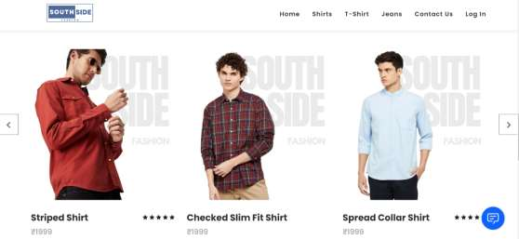

</script>

<script>

window.watsonAssistantChatOptions = {

integrationID: "614a4315-ff80-4187-8fe4-2fd9b506b723", // The ID of this integration.

region: "au-syd", // The region your integration is hosted in.

serviceInstanceID: "9670dcf8-789f-4609-8d7a-6e25c412a9ec", // The ID of your service instance.

onLoad: function(instance) { instance.render(); }

};

setTimeout(function(){

const t=document.createElement('script');

t.src="https://web-chat.global.assistant.watson.appdomain.cloud/versions/" + (window.watsonAssistantChatOptions.clientVersion || 'latest') +

"/WatsonAssistantChatEntry.js";

document.head.appendChild(t);

});

</script>

</body>

<footer>

<divclass="footer"> <H1>HAPPY SHOPPING</H1></div>

</footer>

</html>

**OUTPUTS:**

33

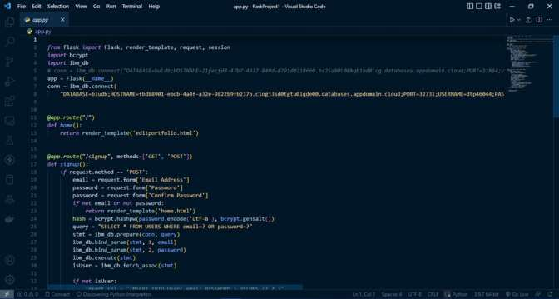

**7.3** **DATABASE** **SCHEMA:**

34



**8.** **TESTING**

8.1 TEST CASES

35

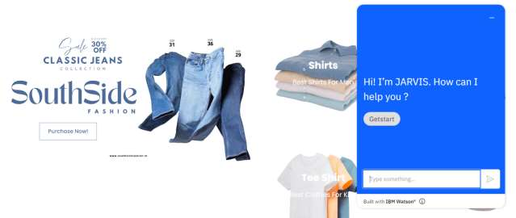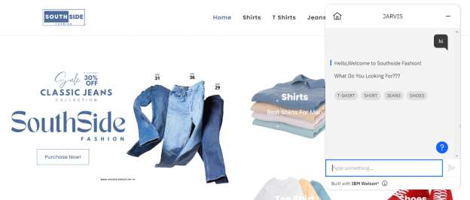

8.2 USER ACCEPTANCE TESTNG

36



**9.** **RESULTS**

**PERFORMANCE** **METRICS:**

The performance of a recommendation algorithm is evaluated by using some specific metrics that indicate the accuracyof the system. Thetypeof metric used depends on thetypeof filtering technique. Root Mean Square Error (RMSE), Receiver Operating Characteristics (ROC), Area Under Cover (AUC), Precision, Recall and F1 score is generally used to evaluate the performance or accuracy of the recommendation algorithms.

***Root-mean*** ***square*** ***error*** ***(RMSE)***. RMSE is widely used in evaluating and comparing the performance of a recommendation system model compared to other models. A lower RMSE value indicates higher performance by the recommendation model. RMSE, as mentioned by, can be as represented as follows:

where, *Np* is the total number of predictions, *pui* is the predicted rating that a user *u* will select an item *i* and *rui* is the real rating.

***Precision***. Precision can be defined as the fraction of correct recommendations or predictions (known as True Positive) to the total number of recommendations provided, which can be as represented as follows:

It is also defined as the ratio of the number of relevant recommended items to the number of recommended items expressed as percentages.

***Recall***. Recall can bedefined as the fraction of correct recommendations or predictions (known as True Positive) to the total number of correct relevant recommendations provided, which can be as represented as follows:

It is also defined as the ratio of the number of relevant recommended items to the total number of relevant items expressed as percentages.

***F1*** ***Score***. F1 score is an indicator of the accuracy of the model and ranges from 0 to 1, where a value close to 1 represents higher recommendation or prediction accuracy. It represents precision and recall as a single metric and can be as represented as follows:

***Coverage***. Coverage is used to measure the percentage of items which are recommended by the algorithm among all of the items.

***Accuracy***. Accuracy can be defined as the ratio of the number of total correctrecommendations to the total recommendations provided, which can be as represented as follows:

37

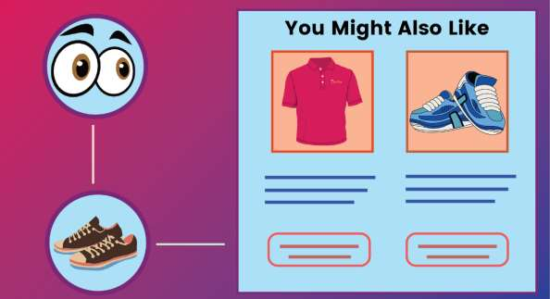

**10.** **ADVANTAGES** **&** **DISADVANTAGES**

**ADVANTAGES:**

• Smart fashion recommender application is the user friendly.

• With the help of chat-bot user can find the products very easily.

• This application used to discover the product based on the user’s choice

, veryeasily and quickly.

• It has the abilityto reduce transaction costs for consumers, and

increase revenue for-retailers.

**DISADVANTAGES:**

• It needs active internet connection.

• Privacy concerns.

• Too many choices.

• Cold-start problem.

38

**11.CONCLUSION**

TheFashion Recommendation System is mainlyused to recommend the best possible outfit

combinations to a user who has no fashion sense based on their wardrobe . It may not always

providethe best possible outfit to wear foran occasion as the system is dependent completelyon

the clothes present in the user’s wardrobe. Also another reason is that fashion ishighly

dependent on the time period. However the system does a great job in inculcating a fashion

senseamongthe users and can providethe best recommendations based on the user’s wardrobe.

Since the system is implemented as a website, it is very easy for the end users to access as well

as use. The scope of this system can be expanded by including the ability to detect the various

design and patterns on clothing, and to increase the number ofoccasions.

**12.FUTURE** **SCOPE**

In the future, to implement this recommendation system to be extended to include male

and non-binary fashion items including apparel, footwear, accessories etc. This work can

further be enhanced to predict fashion items based on the skin colour and weather conditions.

Future research should concentrate on including time series analysis and accurate

categorization of product images based on the variation in colour, trend and clothing style in

order to develop an effective recommendation system. The proposed model will followbrand-

specificpersonalizationcampaigns andhenceitwillensurehighlycurate and tailored.offerings

for users. Hence, this research will be highly beneficial for researchers interested in using

augmented and virtual reality features to develop recommendation systems.

39

**13.** **APPENDIX** **SOURCE** **CODE:**

**login.html:**

<html> <head>

<meta name="viewpoint" content="width=device-width, initial-scale=1.0"> <title>BEYOND FASHION</title>

<link rel="stylesheet" href="https://storagedemo-madzh.s3.jp-tok.cloud-object storage.appdomain.cloud/Regcss.css">

</head>

<body>

<div class="main"> <divclass="navbar">

<divclass="menu"> <ul>

</ul> </div> </div>

<div class="content">

<h1> SMART FASHION <br><span>APPLICATION</span></h1> <div class="form">

<h2>FASHIONISTA LOGIN</h2> <form action="/Login" method="post">

<input type="text" name="username" placeholder="ENTER USERNAME"> <input type="password" name="password" placeholder="ENTER PASSWORD"> <button type="SUBMIT" class="btnn"><a href="#">LOGIN</a></button>

<p class="link">DON'T HAVE AN ACCOUNT<br>

<a href="/Register">SIGN UP </a> HERE </a></p> </form>

</div> </div>

</div> </body> </html>

40

**INTEGRATING** **APPLICATION** **WITH** **CHATBOT** **USING** **WATSON** **ASSISTANT**

CODE :

<script> window.watsonAssistantChatOptions = {

integrationID: "ee314c2a-5a94-478a-81f9-1d1ea517f1f4", // The ID of this integration. region: "au-syd", // The region your integration is hosted in.

serviceInstanceID: "bb6b3c2a-4354-4525-86b7-75182ccca92e", // The ID of your service instance. onLoad: function(instance) { instance.render(); }

}; setTimeout(function(){

const t=document.createElement('script');

t.src="https://web-chat.global.assistant.watson.appdomain.cloud/versions/" + (window.watsonAssistantChatOptions.clientVersion || 'latest') + "/WatsonAssistantChatEntry.js"; document.head.appendChild(t);

}); </script>

**GITHUB**

**GITHUB** **LINK:**

**https://github.com/IBM-EPBL/IBM-Project-49293-1660817543**

41

42